Design outline for Computer-Based Training on Systematic Instructional Design Process

Prepared for
New Oriental Training Group

#12, Blvd Gaode, Haidian District
Beijing, 100083, P.R. China
Tel: 010-82036600
Fax: 010-82038125

Project for EME6415, spring 2005
Jing Wang
Instructional Systems
Florida State University

Introduction
1. Background information

Established in 1993 as a small English training school Beijing, New Oriental Education Group (NOEG) is now the most prestigious private training group in China and owns 15 training schools in Chinese Mainland and 2 in Canada. Its business ranges from short-term foreign language training, long-term degree education, IT training, K-12 bilingual education, distance learning, and software development. Each year, over 250,000 people in total choose to take the training courses provided by NOEG. New Oriental’s rapid growth has been regarded as a marvel in China’s education, which once brought an upsurge in research of the “New Oriental Phenomenon” in Chinese academia.

Though the success has been phenomenal, the current instructional design process that has been practiced by NOEG is inconsistent and ineffective. Therefore, a change project is proposed to help NOEG adopt a systematic instructional design model in order to solve the problem.

Part of the change project plan is that NOEG should deliver a computer-based self-study training course for all instructors. The goal of the training is to gain the instructors’ support for the change project, and to prepare them with basic knowledge of the systematic instructional design model (Dick and Carey model) and facilitate the knowledge transfer to their daily teaching practice. But they will not be the actual designers of the instruction. There will be a separate ID Office to take responsibility of the whole instructional design process.

This document includes a general outline of the course, storyboard for course overview and Module 4, and several sample screens. The document will be included in appendices to the change project proposal I’ve prepared for NOEG and serve as a communication tool.
2. Learner analysis
The target learners of the training module are the instructors in the field of language training in NOEG.
Information category | Learner characteristics/related comments
- Age | Between 25 and 40
- Educational level | All the instructors in NOEG have at least a Bachelor’s degree from accredited universities in China; quite of few of them have Master’s degrees or PH.D. degrees
- Prior knowledge | None, because the notion of systematic Instructional Design is foreign to the educational field in China
- Attitudes towards computer-based training | Supportive or at least neutral. NOEG offer many online courses and quite a few instructors have online teaching experience
- Motivation | Moderate to high.  Relevance-Most instructors are actively seeking for opportunities of part-time training and better career development; therefore they will regard this training as a valuable opportunity.  Confidence-Most instructors are very confident in their learning ability.  Attention- It would be a challenging task to maintain their attention since they are taking the course after work.
- General learning preferences | 1. Do not have time for long, extensive training due to full working schedule. Prefer to achieve as much learning results as possible in a short period of time.  2. Unavailable for synchronous interaction.
- Attitudes towards organization | Regard NOEG as pioneer in private training in China. Enthusiastic to changes that may result in better organization performance
- Technology | Every learner has a computer or laptop. But not every learner has internet access at home.  All the learners use MS Windows operating systems on their computers/laptops.

Important instructional design decisions
- Course outline:
  - The course will cover all components of the Dick and Carey model. It will consist of ten modules plus course overview and summary (Figure 1)
Figure 1. Course outline

  - Each module will cover one step in the Dick and Carey Design Model. It will consist of an introduction, major instruction of the subject matter and a quiz.
  - There will not be a final quiz for the whole course, considering the time limit and the characteristics of the target audiences.
- Length of the course: The length of each module will be 45 minutes at the most. The course introduction and summary will be 30 minutes each. Therefore the whole course will be no longer than 8.5 hours.
- Delivery method: CD, considering the fact that not every learner will have internet access at home.
- CBT design principles: The design of the course should comply with the major principles in E-learning and Science of Instruction (Clark, R.C. and Mayer, R. E., 2003).
  - Multimedia principle: use words and graphics rather than words alone
  - Contiguity principle: place corresponding words and graphics near each other
  - Redundancy principle: present words in either audio or text form, but not both at the same time. However, when important information is presented in audio, key points will be presented as onscreen text as well. Change in audio and text can also help to maintain learner’s attention.
  - Coherence principle: avoid using unrelated materials (sound, clip arts, etc)
- Interaction: Interaction will take the form of leaner-content interaction.
- Learner control: learners are free to decide what to learn (content) and how to learn (timing and sequence) considering their high ability of self-regulation.
- Color and animation: as least as possible. Try to make the course simple and easy to follow.

Storyboard for course introduction
Screen 1. Course overview
Content of the screen | Programmer Notes
Welcome to the course on systematic instructional design!  How do I proceed?  The whole course will take 9 hours in total. You may choose to start by click links in the following menu.  You can also proceed by clicking the “” button at the bottom of each page; you can return to the previous page by clicking the “” button. And at any point while you are taking the course, you can return to this menu by clicking the button.  Course Menu  Introduction to Instructional Design  Module 1.  Module 2.  Module 3  Module 4  Module 5  Module 6  Module 7  Module 8  Module 9  Module 10  Course summary | Link the underlined words in the course menu to the corresponding section of the course. For example, when the learner clicks Module 1, it will direct the learner to the first screen of Module 1.
Script for audio: (start as soon as the screen is accessed)
Hi! Welcome to the self-study course on the systematic instructional design process!
In this course, you will learn about all the components of the Dick and Carey instructional design model. By the end of this course, you will be able to:
- State the ten components of the Dick and Carey Design Model.
- State the definition of each step of the model
- List substeps to complete each step
- Apply some of the ideas you gained from this course to your instructional practice.
Please read the instruction on “how do I proceed” before you go on to the next page.

Screen 2. Introduction to Instructional Design-1
Content of the screen | Programmer Notes
What is the traditional perspective of instruction? | Hand-shaped pointer when mouse over; When the link is clicked, change color and present the following information in audio: “The instructional process, or teaching, has traditionally involved instructors, learners, and textbooks. The content to be learned was contained in the text, and it was the instructor's responsibility to "teach" that content to the learners. Teaching could be interpreted as getting content from the text into the heads of learners in such a way that they could retrieve the information for a test.”
What is a systems approach to designing instruction?  (the following are subtitles, smaller fonts, indented)  What is a system?  How is it related to instruction?  What is Instructional Systems Design (ISD)? | Hand-shaped pointer when mouse over each link.  When the link “What is a systems approach to designing instruction?” is clicked, change color and present the following information in audio: “A more contemporary view of instruction is that it is a systematic process in which every component (i.e., teacher, learners, materials, and learning environment) is crucial to successful learning. This perspective is usually referred to as the systems point of view, and advocates of this position typically use the systems approach to design instruction.”  When the link “What is a system?” is clicked, change color and present the following information in audio: “A system is technically a set of interrelated parts, all of which work together toward a defined goal. The parts of the system depend on each other for input and output, and the entire system uses feedback to determine if its desired goal has been reached. If it has not, then the system is modified until it does reach the goal. The most easily understood systems are those we create rather than those that occur naturally. For example, you probably have a heating or cooling system in your home that consists of various components that work together to produce warmth or coolness. The thermostat is the feedback mechanism through which the thermometer constantly checks the temperature and signals the system when more heat or cold is needed. When the desired temperature is reached, the system shuts itself off.”  When the link “What is a system?” is clicked, change color and present the following information in audio: “First, the instructional process itself can be viewed as a system. The purpose of the system is to bring about learning. The components of the system are the learners, the instructor, the instructional materials, and the learning environment. These components interact in order to achieve the goal. For example, the instructor reviews sample problems in the textbook or manual with the learners in a quiet classroom. To determine whether learning is taking place, a test is administered. This is the instructional system thermostat. If learner performance is not satisfactory, then changes must be enacted to make the system more effective and to bring about the desired learning outcomes.”  When the link “What is a system?” is clicked, change color and present the following information in audio:  “A number of models bear the label systems approach, and all of them share most of the same basic components. The systems approach model presented in this book is less complex than some but includes the major components included in other models. Collectively, these design models and the processes they represent are referred to as Instructional Systems Development (ISD).”
Why use a systems approach? | Hand-shaped pointer when mouse over; When the link is clicked, change color and present the following information in audio: “there are a number of reasons that systematic approaches to instructional design are effective. The first is the focus, at the outset, on what learners are to know or be able to do when the instruction is concluded. Without this precise statement, subsequent planning and implementation steps can become unclear and ineffective. A second reason for the success of the systems approach is the careful linkage between each component, especially the relationship between the instructional strategy and the desired learning outcomes. Instruction is specifically targeted on the skills and knowledge to be taught and supplies the appropriate conditions for the learning of these outcomes. Stated another way, instruction does not consist of a range of activities only some of which may be related to what is to be learned. The third and perhaps most important reason for the success of the systems approach is that it is an empirical and replicable process. Instruction is designed not for one delivery, but for use on as many occasions as possible with as many learners as possible. Because it is reusable, it is worth the time and effort to evaluate and revise it. In the process of systematically designing instruction, data are collected to determine what part of the instruction is not working, and it is revised until it does work. Because of these characteristics, the systems approach is valuable to instructors who are interested in successfully teaching basic and higher level competencies to learners.”
Script for audio: (start as soon as the screen is accessed)
In this section, you will get a brief introduction of the field of instructional design. Please choose the topic you would like to learn by clicking the link on the screen.

Screen 3. About Dick and Carey Model
Content of the screen | Programmer Notes
Dick and Carey Model  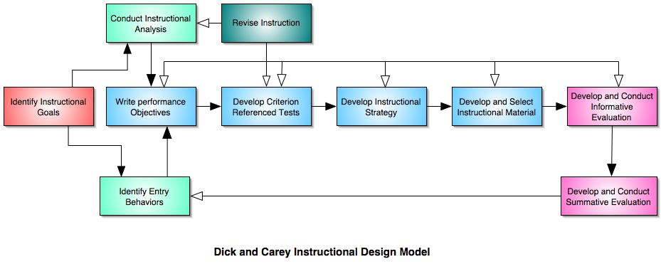  (Text that will occur in bubble form when mouse over the box “lDENTIFY INSTRUCTIONAL GOAL(S)” )  The first step in the model is to determine what it is that you want learners to be able to do when they have completed your instruction. The instructional goal may be derived from a list of goals, from a needs assessment, from practical experience with learning difficulties of students, from the analysis of people who are doing a job, or from some other requirement for new instruction.  (Text that will occur in bubble form when mouse over the box “CONDUCT INSTRUCTIONAL ANALYSIS”)  After you have identified the instructional goal, you will determine step-by- step what people are doing when they perform that goal. The final step in the instructional analysis process is to determine what skills, knowledge, and attitudes, known as entry behaviors, are required of learners to be able to begin the instruction. A diagram will be produced that depicts the relationships among all of the skills that have been identified.  (Text that will occur in bubble form when mouse over the box “ANALYZE LEARNERS AND CONTEXTS”)  In addition to analyzing the instructional goal, there is a parallel analysis of the learners, the context in which they will learn the skills, and the context in which they will use them. Learners' current skills, preferences, and attitudes are determined along with the characteristics of the instructional setting and the setting in which the skills will eventually be used. This crucial information shapes a number of the succeeding steps in the model, especially the instructional strategy.  (Text that will occur in bubble form when mouse over the box “WRITE PERFORMANCE OBJECTIVES”)  Based on the instructional analysis and the statement of entry behaviors, you will write specific statements of what the learners will be able to do when they complete the instruction. These statements, which are derived from the skills identified in the instructional analysis, will identify the skills to be learned, the conditions under which the skills must be performed, and the criteria for successful performance.  (Text that will occur in bubble form when mouse over the box “DEVELOP ASSESSMENT INSTRUMENTS “)  Based on the objectives you have written, develop assessments that are parallel to and measure the learners' ability to perform what you described in the objectives. Major emphasis is placed on relating the kind of behavior described in the objectives to what the assessment requires.  (Text that will occur in bubble form when mouse over the box “DEVELOP INSTRUCTIONAL STRATEGY”)  Based on information from the five preceding steps, identify the strategy that you will use in your instruction to achieve the terminal objective. The strategy will include sections on pre-instructional activities, presentation of information, practice and feedback, testing, and follow-through activities. The strategy will be based on current theories of learning and results of learning research, the characteristics of the medium that will be used to deliver the instruction, content to be taught, and the characteristics of the learners who will receive the instruction. These features are used to develop or select materials or to develop a strategy for interactive classroom instruction.  (Text that will occur in bubble form when mouse over the box “DEVELOP AND SELECT INSTRUCTIONAL MATERIALS”)  In this step you will use your instructional strategy to produce the instruction. This typically includes a learner's manual, instructional materials, and tests. (When we use the term instructional materials we are including all forms of instruction such as instructor's guides, student modules, overhead transparencies, videotapes, computer-based multimedia formats, and web pages for distance learning. We intend the term materials to have this broad connotation.) The decision to develop original materials will depend on the type of learning to be taught, the availability of existing relevant materials, and developmental resources available to you. Criteria for selecting from among existing materials are provided.  (Text that will occur in bubble form when mouse over the box “DESIGN AND CONDUCT TBE FORMATIVE EVALUATION OF INSTRUCTION”)  Following the completion of a draft of the instruction, a series of evaluations is conducted to collect data that are used to identify how to improve the instruction. The three types of formative evaluation are referred to as one-to- one evaluation, small-group evaluation, and field evaluation. Each type of evaluation provides the designer with a different type of information that can be used to improve the instruction. Similar techniques can be applied to the formative evaluation of existing materials or classroom instruction.  (Text that will occur in bubble form when mouse over the box “REVISE INSTRUCTION”)  The final step (and the first step in a repeat cycle) is revising the instruction. Data from the formative evaluation are summarized and interpreted to attempt to identify difficulties experienced by learners in achieving the objectives and relate these difficulties to specific deficiencies in the instruction. The line in the figure on pages 2 and 3 labeled "Revise Instruction" indicates that the data from a formative evaluation are not simply used to revise the instruction itself, but are used to reexamine the validity of the instructional analysis and the assumptions about the entry behaviors and characteristics of learners. It is necessary to reexamine statements of performance objectives and test items in light of collected data. The instructional strategy is reviewed and finally all this is incorporated into revisions of the instruction to make it a more effective instructional tool.  (Text that will occur in bubble form when mouse over the box “DESIGN AND CONDUCT SUMMATIVE EVALUATION”)  Although summative evaluation is the culminating evaluation of the effectiveness of instruction, it generally is not a part of the design process. It is an evaluation of the absolute and/ or relative value or worth of the instruction and occurs only after the instruction has been formatively evaluated and sufficiently revised to meet the standards of the designer. Since the summative evaluation usually does not involve the designer of the instruction but instead involves an independent evaluator, ibis component is not considered an integral part of the instructional design process per se. | Mouse over each box of graphic:  Highlight the box and show a brief introduction of each step of the model in a bubble.
Script for audio: (start as soon as the screen is accessed)
Among various instructional design models, the Dick and Carey model is one of the most widely used instructional design models in the United States; and it has been proved viable across military, business and educational settings.
There are ten steps in the Dick and Carey Model. To read about a general overview of each of the 10 steps, please put the mouse pointer over each step in the model.

Storyboard for Module 4
Screen 1. Introduction of Module 4
Content of the screen | Programmer Notes
Module 4. Write performance objectives  Welcome to Module 4!  This module will teach you how to write performance objectives, which is the fourth step in the Dick and Carey Model.  By the end of this module, you will be able to:  - Differentiate between the terms terminal objective and enabling objectives.  - Name and describe the components of a properly written performance objective.  - Write a performance objective properly.  This module includes the following sections:  Section 1: what is a performance objective?  Section 2: why are performance objectives important?  Section 3: what are the three components of a performance objective?  Section 4: when do I write performance objectives?  Section 5: quiz | Link the sections to corresponding pages.
Script for audio: (start as soon as the screen is accessed)
Welcome to Module 4! It is important for an instructor to know how to write performance objectives properly. By the end of this module, you will be able to:
- Differentiate between the terms terminal objective and enabling objectives.
- Name and describe the components of a properly written performance objective.
- Write a performance objective properly.
Screen 2 what is a performance objective?
Content of the screen | Programmer Notes
Section 1. What is a performance objective?  A performance objective is a detailed description of what students will be able to do (desired performance during or after the training).  • Terminal Performance Objectives (TPOs)  (shown in bubble when clicked)  TPOs are based on the task statements from an FEA or JTA and describe what the student will be able to do upon completion of instruction. The word “terminal” is used as a descriptor because a TPO describes the terminal or ”end” performance the student should have mastered upon completion of instruction.  • Enabling Objectives (EOs)  (shown in bubble when clicked)  EOs are written at the task step (or groups of task steps) level and support the TPO. The word “enabling” is used as a descriptor because mastering an EO brings the student closer to mastery of the TPO. | Hand-shaped pointer when mouse over; change color and show related text in Italic in bubble when clicked.
Script for audio: (start as soon as the screen is accessed)
A performance objective is a detailed description of what students will be able to do (desired performance during or after the training). There are two types of performance objectives, terminal performance objectives and enabling objectives. To learn more about each, please click on the links on the screen.

Screen 3 why are performance objective so important?
Content of the screen | Programmer Notes
Section 2. Why are performance objective so important?  You will gain several benefits from writing performance objectives:  - They direct subsequent training program development.  - They direct how you train your students.  - They tell both you and the students how they are going to be tested and evaluated.  Performance objectives form the basis of your design. | Animation effect: fly in one by one, accompanied by audio presentation of the content. For example, “1 They direct subsequent training program development” flies in when the audio presentation of it starts.
Script for audio: (start as soon as the screen is accessed)
Performance objectives are the foundation of a training course. They help convert real world performance into useful and transferable training--both for the instructor and for the student.
You will gain several benefits from writing performance objectives:
- They direct subsequent training program development.
- They direct how you train your students.
- They tell both you and the students how they are going to be tested and evaluated.
In one word, performance objectives form the basis of your design.

Screen 4 what are the three components of a performance objective?

Content of the screen | Programmer Notes
Section 3. What are the three components of a performance objective?  Every performance objective has three parts:  - Performance (task statement--what the student is expected to do)  - Condition(s) (limits/conditions within which the student is expected to perform)  - Criteria (how well the student is expected to perform) | (for text after “Every performance objective has three parts”)  Animation effect:  Fly in one bullet each time, accompanied with audio presentation.  Hand-shaped pointer when mouse over “performance” “conditions” and “criteria”; change color when clicked.  When clicked, the ink performance directs the learner to screen 5; conditions to screen 6, criteria to screen 7.
Script for audio: (start as soon as the screen is accessed)
Every performance objective has three parts:
1. Performance. It is a task statement, describing what the student is expected to do.
2. Condition(s). It includes limits/conditions within which the student is expected to perform.
3. Criteria. It describes how well the student is expected to perform.
To learn more about each component, please click on the team underlined.

Screen 5 three components-continued
Content of the screen | Programmer Notes
Performance  Performance is an observable behavior identified in the instructional analysis. The objective must describe what the learner will be able to do by the end of the training. This component contains both the action and the content or concept.  To write this part of the TPO:  • Define the observable behavior you want the student to do.  • (Ideally), use the same task statement that came from Job-task analysis.  • If you can’t use that statement because of varying constraints, define a statement that is as close as possible to the performance desired in the real world.  All performance statements must include an action word (verb) plus an object (a noun).  Click here to see an example. | Click here to see an example:  Hand-shaped pointer when mouse over “here”; change color and show the following text in Italic in bubble on the same screen:  For example, if the task FEA or JTA identified is:  Conduct freight vessel exams. But, you have to train that task in a classroom setting where you won’t have the equipment or time to actually conduct freight vessel exams, convert the task statement  to:  • Determine regulatory compliance by completing a boarding form.  Conduct (action word--verb) + freight vessel  exams (object--noun) or  Determine (action word--verb) + regulatory compliance (object--noun)

Screen 6 three components-continued
Content of the screen | Programmer Notes
Condition(s)  The conditions statement describes the givens, situations or scenarios, and restrictions under which the task will be performed. Just as with the performance statement, you won’t always be able to match training conditions to conditions in the actual performance context. However, you want to make conditions as similar to the real performance context as possible.  To write this part of the TPO:  • Consider the actual performance of the task as it is done in the real world.  • Replicate those conditions (including tools and equipment) as closely as possible.  • Add any conditions that match how the task will be done in a classroom, lab, or alternative delivery setting (e.g., “darkened lab to simulate night operations”)  The condition statement is usually started by the word “given”.  Click here to see examples. | Click here to see examples:  Hand-shaped pointer when mouse over “here”; change color and show the following text in Italic in bubble on the same screen:  Examples of conditions:  - Given the term and a set of alternative definitions (in bold), select the most precise definition.  - Given a written word (in bold), correctly pronounce it.  - Given a map and ruler (in bold), calculate the linear distance between two cities.

Screen 7 three components-continued
Content of the screen | Programmer Notes
Criteria  The Criteria statement describes the minimum acceptable level of trainee performance. Standards are written in terms of quantity, quality, accuracy, and limits.  To write this part of the TPO:  • Determine the level of competence to which you want the student to perform. Base that level of competency on the level required for the actual performance context.  Some ways to measure the competence of a performance are  Limits: examples: Within 5 minutes, [type] 40 words per minute, within 3 attempts.  • Quantity: example: Enter at least three violation reports within an hour.  • Accuracy: examples: Without error, answer at least three out of four correctly.  • Quality: steps must be performed in proper sequence; measurement must be within specified tolerance, note 80% of the possible discrepancies. | “Criteria”- in bold  “To write this part of the TPO” in bold  “measure the competence”  “limits”  “quantity”  “Accuracy”  “Quality”  in bold

Screen 8 Section 4: when do I write performance objectives?

Content of the screen | Programmer Notes
Section 4: when do I write performance objectives?  You write performance objectives:  • Once you complete or receive task analysis worksheets and content analysis results.  • When you need to develop or revise a curriculum outline.  • When you are doing design work for traditional or alternative delivery instruction. | Animation effect: fly in one by one, with a 5 seconds’ interval.

Screen 9. Section 5: a quiz-introduction

Content of the screen | Programmer Notes
This online quiz helps you make certain that you have mastered the content presented in this module.

(Add an action button, link to next screen)
take the quiz

Screen 10 quiz continued

Content of the screen | Programmer Notes
Judge the completeness of given performance objectives. Read each of the objectives listed below, and judge whether each objective includes conditions, performance, and a criterion. If any element is missing, click item number (a, b, c, d, or e) in front of the part(s) omitted. You will only be allowed to proceed to the next module once you have answered all questions correctly.  - Given a list of activities carried on by the early settlers of North America, understand what goods they produce, what product resources they used, and what trading they did. The following is/are missing from the objective:  - important conditions and criterion  - performance and important conditions  - performance and criteria (correct answer)  - nothing  (Add an action button, link to next screen)  next question | PROGRAMMING:  Learner cannot move on to the next module until all questions are finished and feedback is checked.  Make the options(a, b, c, d, and e) clickable.

Screen 11 quiz continued
Content of the screen | Programmer Notes
- Given a mimeographed list of states and capitals, match at least 35 of the 50 states with their capitals without the use of maps, charts, or lists. What is missing from this objective?
  - Performance
  - Conditions
  - Criterion
  - nothing

(Add an action button, link to next screen)
next question

Screen 12 quiz continued
Content of the screen t | Programmer Notes
- During daily business transactions with customers, know company policies for delivering friendly, courteous service. Which of the following is missing form this objective?
  - Performance
  - Conditions
  - Criterion
  - a and b
  - a and c

(Add an action button, link to next screen)
next question

Screen 13 quiz continued
Content of the screen | Programmer Notes
- Students will be able to play the piano. Which of the following is missing from this objective?
  - Conditions
  - Conditions and criterion
  - Performance and criterion
  - Nothing

(Add an action button, link to next screen)
next question

Screen 14 quiz continued
Content of the screen | Programmer Notes
- Given daily access to music in the office, choose to listen to classical music at least half the time. Which of the following is missing from this objective?
  - Conditions
  - Performance
  - Criterion
  - Nothing

(Add an action button, link to next screen, will only be activated when all questions are answered) CHECK ANSWER
Screen 15 quiz feedback

Content of the screen | Programmer Notes
- c  - d  - e  - b  - d  (Add an action button, link to next screen)  Next Module | When the learner gets a questions wrong, display the following message:  That’s not correct. The right answer should be <depending on the question>.  When the learner gets all answers correct, display the following message:  Great job! You got all of the questions correct. Now you are ready to move on to the next module.

A few sample screens are included in Appendix 1.
Appendix 1. Sample Screens

Sample screens for Course introduction
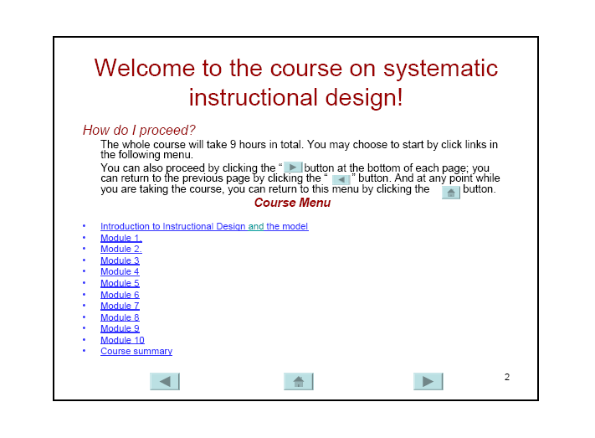
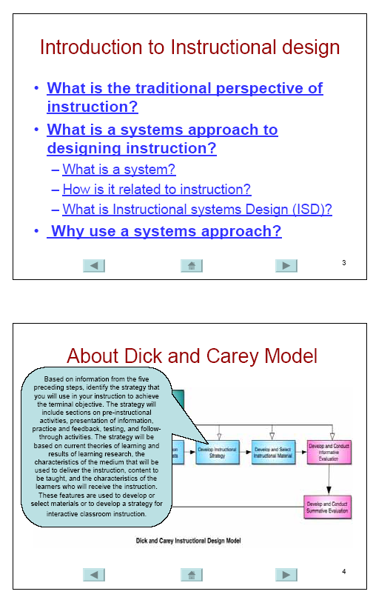
Sample screen for the Quiz-Module 4
